**Promotional Toolkit**

This toolkit contains resources to help promote the Celebrating Reconciliation Grants 2025

Acknowledgment of Country

We pay our respects to the Aboriginal and Torres Strait Islander ancestors of this land, their spirits and their legacy. The foundations laid by these ancestors—our First Nations peoples—gives strength, inspiration and courage to current and future generations, towards creating a better Queensland.

# About the grants

The Celebrating Reconciliation Grants Program is designed to support events and activities held in or around National Reconciliation Week.

Key criteria for events and activities are to:

* promote and facilitate respectful relationships between Aboriginal, Torres Strait Islander and non-Indigenous Queenslanders
* promote inclusion through strengthening relationships between Aboriginal, Torres Strait Islander and non-Indigenous Queenslanders
* raise community awareness of National Reconciliation Week, held annually from 27 May to 3 June
* offer community members opportunities to learn, share, and grow—for example, through sharing stories, and showcasing local Aboriginal and Torres Strait Islander histories, arts and cultural activities.

The Celebrating Reconciliation Grants 2025 will support Queensland-based reconciliation events held in or around National Reconciliation Week 2025. Organisations will be able to apply for grants of $2,500 (exclusive of GST) per event. A total of $75,000 in grant funding is available.

# Key messages

* National Reconciliation Week, held annually from 27 May to 3 June, celebrates and builds on respectful relationships shared by Aboriginal, Torres Strait Islander and non-Indigenous Australians.
* The week is an opportunity for all Australians to learn about our shared histories, cultures and achievements and to explore how each of us can join the national reconciliation effort.
* The Celebrating Reconciliation Grants supports Queensland-based reconciliation events held in or around National Reconciliation Week 2025 (in May or June).
* Grants are available to the value of $2,500 (exclusive of GST) per event or activity.
* Applications open at 8:00am on Monday 7 April 2025.
* Applications close at 8:00am on 22 April 2025.

# Key dates

* At 8:00am on Monday 7 April 2025: Grant applications open
* At 8:00am on 22 April 2025: Grant applications close
* On 14 May 2025: Grant recipients announced
* May to June 2025: National Reconciliation Week events

# Promotional Assets

This toolkit provides content and promotional assets (e.g. newsletter content and social media images) that can be used to raise awareness of the Celebrating Reconciliation Grants and encourage applications.

[Download the promotional assets here.](https://www.tatsipca.qld.gov.au/about/news-media/promotional-assets)

This promotional URL (short URL) will direct people through to existing campaign web content.

[www.qld.gov.au/**recgrants**](http://www.qld.gov.au/recgrants)

## Newsletter content

**Applications now open for Celebrating Reconciliation Grants**

The Queensland Government Celebrating Reconciliation Grants are now open with $75,000 in funding available to help Queensland communities come together for National Reconciliation Week, 2025.

Eligible organisations can apply for grants of $2,500 for events that support reconciliation between Aboriginal, Torres Strait Islander and non-Indigenous Queenslanders.

Celebrating Reconciliation Grants supports Queensland-based reconciliation events held in or around National Reconciliation Week (27 May to 3 June).

Applications open at 8:00am on Monday 7 April 2025 and close at 8:00am on 22 April 2025.

To find out more about the Celebrating Reconciliation Grants, including how to apply, visit www.qld.gov.au/recgrants

### [Newsletter image](https://www.tatsipca.qld.gov.au/about/news-media/promotional-assets)

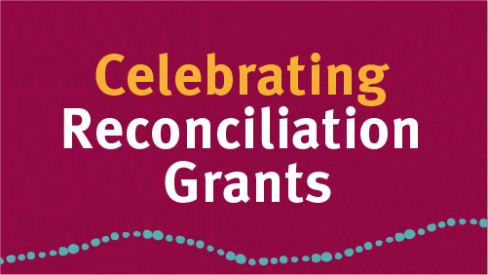

## Website content

The Queensland Government Celebrating Reconciliation Grants are now open.

Grants of $2,500 are available to support National Reconciliation Week events and activities across Queensland. Applications close at 8:00am on 22 April 2025.

National Reconciliation Week (27 May to 3 June) celebrates and builds on respectful relationships shared by Aboriginal, Torres Strait Islander and non-Indigenous peoples.

To find out more, more visit [www.qld.gov.au/recgrants](http://www.qld.gov.au/recgrants)

### [Web image](https://www.tatsipca.qld.gov.au/about/news-media/promotional-assets)

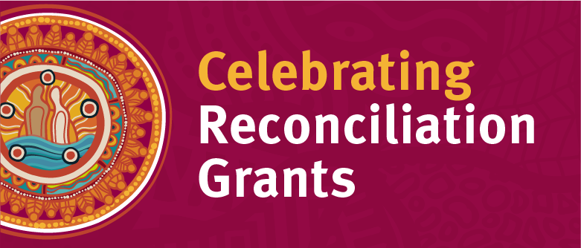

## Social Media

Do you have an idea for an event or activity that promotes reconciliation between Aboriginal and Torres Strait Islander Queenslanders and non-Indigenous Queenslanders?

Applications are now open for the Celebrating Reconciliation Grants, proudly supported by the Queensland Government to help communities come together for National Reconciliation Week 2025 (27 May–3 June).

Eligible organisations are invited to apply for grants of $2,500 per event or activity.

Apply before 8:00am on 22 April 2025.

Find out more about the program and how to apply at [www.qld.gov.au/recgrants](http://www.qld.gov.au/recgrants)

#QldReconciliationGrants #NRW2025

### [Social media tiles](https://www.tatsipca.qld.gov.au/about/news-media/promotional-assets)

#### Tile A: Apply now

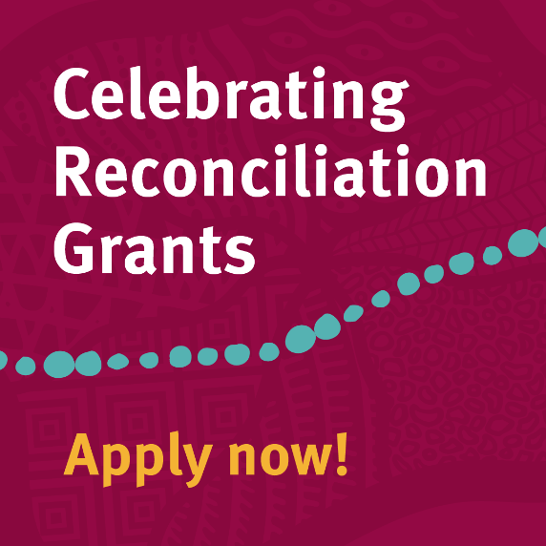

#### Tile B: Hurry, closing soon

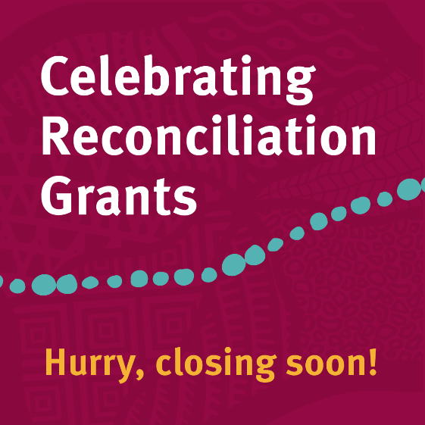

## Additional campaign materials

### [Campaign Poster](https://www.tatsipca.qld.gov.au/about/news-media/promotional-assets)

#### A4/A3

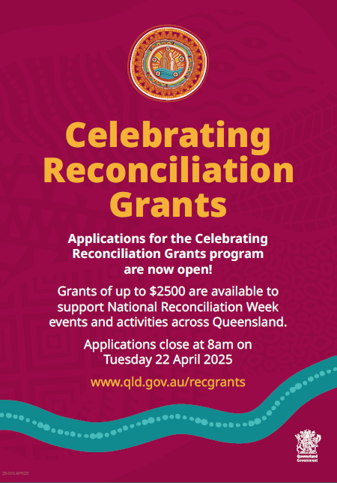

## Further information

For more information about Celebrating Reconciliation Grants contact:

Strategic Communication and Marketing  
Governance and Strategic Communication  
Department of Women, Aboriginal and Torres Strait Islander Partnerships and Multiculturalism

Email: [campaigns@dsdsatsip.qld.gov.au](mailto:campaigns@dsdsatsip.qld.gov.au)